

Business Running Case: Investing in a New BrewPub Part 2

Team 1:

Jiaxing Lin； Yinzhu Jiang； Wenhao Zhou ；Zeyu Zhang； Xiner Cai

Assignment 3 Part 2

AD 715

Boston University

**Table of Contents**

**Executive Summary****2**

**1.Introduction 3**

1.1 Purpose of the Report 3

1.2 Structure of the Report 3

**2. Managerial Decision Process for Selected Functional Areas 4**

2.0 Methodology for Analysis of a Functional Area 4

2.1 Operation Management and Decision Making 4

2.2 Innovation & Technology Management and Decision Making 5

2.3 Organization & HR Management and Decision Making 7

**3. Application of Decision Support Tools per Cycles 8**

3.0 Methodology for Applying Decision Tools per Cycles 8

3.1 Functional Area Operations Management 8

3.1.1 Decision Tools (Applied Before Entering Assumptions) 8

3.1.2 Decision Tools (Applied After the Submission of a Cycle) 10

3.2 Functional Area Innovation & Technology Management 11

3.2.1 Decision Tools (Applied Before Entering Assumptions) 11

3.2.2 Decision Tools (Applied After the Submission of a Cycle) 13

3.3 Functional Area Organization and HR Management 15

3.3.1 Decision Tools (Applied Before Entering Assumptions) 15

3.3.2 Decision Tools (Applied After the Submission of a Cycle) 15

**4. Evaluation of the cycle 17**

4.1 How Changes Made in Different Functional Area 17

4.2 Best Cycle Analysis 18

**5. Summary 1****9**

5.1 Summary of the Results 19

5.2 Recommended Strategy 19

5.3 Implementation Plan 19

5.4 Conclusions 19

**Reference 20**

**Appendices 21**

Executive Summary

Due to the competitive market in the New York area, we decided to expand our business with a new brewpub located on Main Street. We conducted a simulation to assess our strategies to find the optimal parameters for the proposed new project. This report outlines the analysis of three key areas: operation management, innovation management and organizational management, providing detailed insights into each process. We developed a comprehensive strategy, combining both market research and analysis to adjust each cycle to achieve the enhancement of sales and revenue during the three fiscal years.

Building upon the assumptions that we made regarding costs and price during the initial 5 cycles, we further optimized these factors to ensure profitability and smoother operation. Throughout the simulation, we found that cut off point adjustment in operational management has a positive impact on balancing our demand and supply along with a significant increase in revenue. After modifying variable and fixed costs in the innovation and organizational management cycles, our net profit after tax has maintained an optimal amount ($891,855) with a shortened break-even period (3.48 months) that satisfied our desired goals both financially and operationally.

After analyzing the result, we recommend investing in the Flushing Ale House as it has shown a consistent and positive increase in profitability. However, it is also necessary to conduct extensive market research including promotion, competitive analysis and factors that influence the internal adjustments in order to optimize business plans and implement strategies for long-term benefits and gain a stronger market position. The implementation plan will cover advertisement via multi-channels, applying innovative strategies in both daily operations and production process, and further investing in human resources.

Managerial Report

# 1.Introduction

Flushing Ale House is a restaurant located on Main Street, New York. To attract more customers and increase the competitiveness of the restaurant, the owner is considering investing in a new BrewPub system. The production of craft beer requires renting additional space and hiring additional production staff, sales force and department managers. The final package price was $150,000.

## 1.1 Purpose of the Report

The purpose of this managerial report is to provide a thorough analysis and evaluation of the feasibility of establishing a microbrewery business on New York's Main Street. The feasibility of investing in a BrewPub will be analyzed by conducting operation management, innovation & technology management, and organization & HR simulations. In addition, the report will identify the potential challenges, opportunities, and risks associated with this business venture through different decision tools.

## 1.2 Structure of the Report

The report will start from methodology of analysis of different functional areas like operation management, innovation & technology management, and organization & HR management. The operation management will adjust the cut off points of different products through Decision Trees and What-If Analysis. Also, the sales projection of each product will be amended based on this. The innovation and technology management will evaluate the impact of process technology changes on the costs and prices via BEP analysis and sensitivity analysis. The organization and HR management will present the adjustment of organizational structure of Flushing Ale House and the change of personnel salary, combined with SWOT analysis. By the end of this report, we will conclude the final decision and recommended strategy for restaurant Flushing Ale House.

# 2. Managerial Decision Process for Selected Functional Areas

## 2.0 Methodology for Analysis of a Functional Area

## 2.1 Operation Management and Decision Making

Operations management relates to the strategic positioning and competitive scope of the organization, which is directly reflected through cost and pricing strategies. (Jacobs & Chase, 2020) Optimal cost control and pricing strategies are determined through a thorough analysis of cost control measures, adjusting for material costs, labor costs and other costs. In BrewPub's case, raw material costs of BR01-01 to BR01-09 ranged from $0.50 to $0.56, labor costs were consistent across all products at$0.30 per unit and other input costs were consistent at$0.30 per unit.

In operations management, it is critical to effectively manage input costs such as labor, materials and other expenses to maximize profitability and one useful tool is to determine an appropriate cut off point. Taking into account the seasonality of different products, marketing effectiveness etc., sales expectations are adjusted in the sales projection for different months. For example, we will reduce the sales projection of BR01-06 Bock Dock in summer because Bock Dock is one of our main products in winter. By doing so, the company can avoid overproduction, which can lead to excess stock and waste. By analyzing historical data and conducting sensitivity analysis, we can identify areas where costs can be reduced without sacrificing quality or efficiency. Other input costs, such as utilities, rent and marketing costs, should also be carefully considered and optimized to obtain maximum impact. By effectively managing input costs and using data-driven decision-making tools, companies can achieve greater efficiency and profitability in their operations.

To determine effective cost control and product pricing strategies, decision tools such as Sensitivity Analysis and What-if Analysis will be used to analyze the impact of cost and revenue changes on the restaurant's operations over the next three years. By utilizing these analytical tools, we can improve the accuracy of our forecasts and make data-driven decisions to improve our operational efficiency, reduce costs and improve long-term profitability.

## 2.2 Innovation & Technology Management and Decision Making

The innovation and technology management can help Flushing Ale House realize its high-level strategic objectives to generate the maximum value for the restaurant (Burgelman, et al., 2008). The innovation management can be realized via process or product technology changes (Burgelman, et al., 2008). In Flushing Ale House, the innovation management will be applied primarily through process technology innovations, in order to help the restaurant achieve the overall cost leadership strategy.

After conducting the comprehensive research, there are three innovative approaches proposed to contribute to the cost reduction in Flushing Ale House. The first innovative approach is to implement a clean-in-place (CIP) system (Craft beer & Brewing, n.d.). This CIP system can automate the cleaning and sanitation of equipment, reducing the time required for these tasks. As a result, the variable cost will be decreased.

The second approach is to leverage the ‘sharing economy’ by utilizing the shared offices, computers, and cars (Marr, 2016). Flushing Ale House can use the shared offices to reduce both rent cost and maintenance expense. Meanwhile, Flushing Ale House can leverage shared computers to reduce the administrative expense. Furthermore, the use of shared cars can reduce the transportation costs and car maintenance expenses. Overall, the use of shared equipment can effectively help Flushing Ale House reduce the variable cost and fixed cost.

The third approach is to use self-service technologies. The self-service technologies will reduce the demand for salesmen, which in turn reduce the labor cost for Flushing Ale House.

Based on the innovation strategies applied above, the variable costs are adjusted in Cycle 8. Both labor cost and other cost of BR01to BR08 are reduced at $0.02, respectively, as shown in Diagram 1. As special offers are less affected by the innovation changes, the labor cost and other costs for the special offer (BR09) remain unchanged.

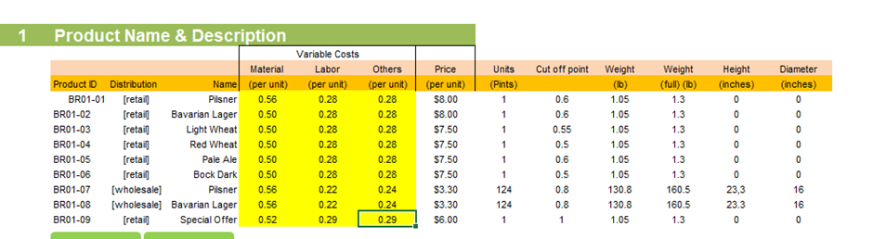

Diagram 1 - Changes on Variable Cost in Innovation Management

In Cycle 9, the fixed costs are adjusted. On the one hand, the budget for office assistants is reduced due to the application of the sharing economy and the budget for salesmen is also decreased due to the use of self-service technologies (see Diagram 2). On the other hand, the leasing of cars and computers, and office supply costs are reduced as shared offices and vehicles are utilized in Flushing Ale House (see Diagram 3). And the use of the CIP system effectively reduces the labor costs and the use of heat, light and phone simultaneously.

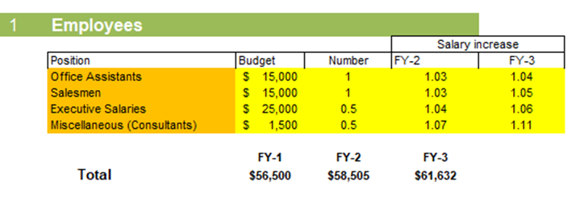

Diagram 2 - Changes on Employee Budget in Innovation Management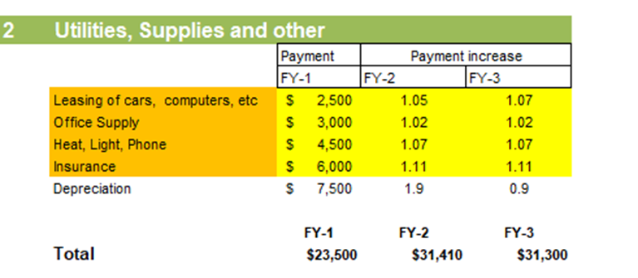

Diagram 3 - Changes on Utilities and Supplies in Innovation Management

## 2.3 Organization & HR Management and Decision Making

Scientific organization structure design and human resource management are the basis to ensure that decisions can be carried out efficiently and with high quality. In the construction of the new investment system, optimizing the organization design and improving the level of human resource management can effectively improve the utilization effect of the new system and enhance the profitability of the enterprise. The design of the organization greatly affects the management flexibility and management efficiency in the new system. The allocation of human resources in an organization affects the work effort of employees, the division of duties and tasks, the clarity of rights and responsibilities, the communication channels between superiors and subordinates, and the allocation of resources. Organizational design involves the structure, processes, and procedures of an organization (Zlatev, 2023), and if organization management is the skeleton of enterprise management, then human resource management is the cell of enterprise management. In the case of BrewPub, in order to achieve our strategic goals, we need to increase marketing costs and control fixed costs, and at the same time, we need to hire additional production staff, sales staff and department managers according to the actual situation, or have staff to cover these responsibilities. We will discuss the optimal decision in the analysis and we will discuss the optimal decision in the simulation and analysis.

# 3. Application of Decision Support Tools per Cycles

## 3.0 Methodology for Applying Decision Tools per Cycles

## 3.1 Functional Area Operations Management

## 3.1.1 Decision Tools (Applied Before Entering Assumptions)

The ratio between Excess Demand and Total Demand is a useful measurement to determine whether the set cut off point is reasonable, and whether the monthly sales projection is allocated to maximize revenue.



Table 1 - FY1 Sales Projection



Table 2 - FY2 Sales Projection



Table 3 - FY3 Sales Projection

The ratio of excess demand to total demand might reveal the amount of demand that is not being supplied by available supply. If the ratio is large, it indicates that there is significant unmet demand, which could mean that the cut-off point is set too low or that there is room to raise output to fulfill demand while maximizing revenue. According to the results of cycle5, it can be seen that the ratio of BR01-03,04,05,06 is more than 10%. Our goal is to ensure that the value of excess demand divided by total demand is between -10% and 10%. This goal can be achieved by first adjusting the cut off point.

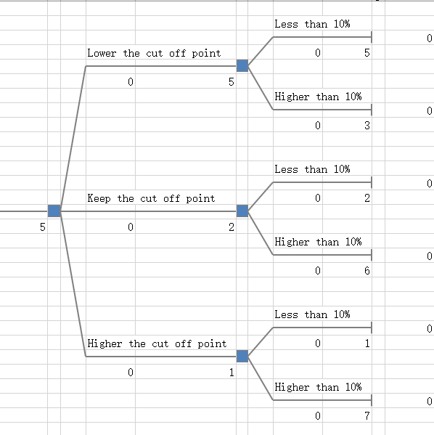

Diagram 4 - Decision Tree Analysis

However, adjusting the cut off point alone will not bring all ratios below 10%, the ratios of BR01-03,04,06 are still way higher than 10%. So we also use What-if Analysis to make adjustments of sales projections for each month to see if there are any changes in the ratio of excess demand and total demand. Take BR01-06 Bock Dock as an example, we firstly adjust its cut-off point to 0.5, and the value of excess demand divided by total demand changed to 34%, which means that the supply is not enough. As this product is our main product for the winter season, we have decided to reduce our monthly sales expectations for the summer months of June and July to a minimum value of 0 on this basis. Another significant change we have made is the expected monthly sales allocation for the BR01-04 Red Wheat. In stark contrast to Bock Dock, Red Wheat is one of our main beers in the summer, so it is expected to sell much higher in the summer than it does in the winter. Based on this assumption, we adjusted Red Wheat's expected sales for January and December to zero and for July and August to 22%, resulting in an ex-process demand to total demand ratio of 1%.

## 3.1.2 Decision Tools (Applied After the Submission of a Cycle)

After running this cycle in the simulation, we could see the generated trend analysis in Tab. Performance (Appendix 1). Our revenue is rising from $741,237 in FY-1 to $877,390 in FY-3, which indicates that our beers are gaining popularity among customers. However, the expenses for FY-3 are also higher than the previous years, which suggests that there may be some cost control issues that need to be addressed. As for the fixed costs, all three years’ fixed costs are substantial and make up a significant portion of the total expenses. It is important to evaluate the fixed costs and determine if there are any areas where costs can be reduced without affecting the quality of the product or the overall customer experience. And the fixed costs structure indicates that the majority of the fixed costs are allocated to marketing and compensation. Thus, we need to review the marketing strategy and ensure that it is effective in reaching the target audience. Additionally, the compensation structure should be evaluated to ensure that it is competitive and aligned with industry standards.

The purpose of the optimization analysis is to obtain a condition in which marginal revenue equals marginal cost. In order to optimize the profits, we performed an optimization analysis within Tab. D-Analysis, trying to find the product price and target market allocation that would maximize our revenue. As a result of the optimization analysis, our revenue increased from $760,583 to $869,736 and consumption deviation decreased from 8.46% to 1.48%. According to the results of the optimization analysis, the market research price of all our products decreased, but it was not much different from the base price we set. Considering the overall revenue, we do not adjust the prices of all products. In addition, the market share is not very different from our original allocation, so we will not change it in the subsequent simulations.

## 3.2 Functional Area Innovation & Technology Management

## 3.2.1 Decision Tools (Applied Before Entering Assumptions)

Prior to the entry of the assumptions, BEP analysis and sensitivity analysis will be conducted for restaurant Flushing Ale House to make the innovation management decisions. BEP analysis is used to help the restaurant owner identify the point when the total revenue equals the total cost. In addition, BEP analysis can help the owner of Flushing Ale House better understand the time period required to break even. From the simulation, when the total revenue achieves at an amount of $213,167, the new investment in the innovation strategies can break even, with a total contribution margin of 77.26%, as shown in Diagram 6. And it will take 3.45 months to break even for the new process technologies used in innovation.

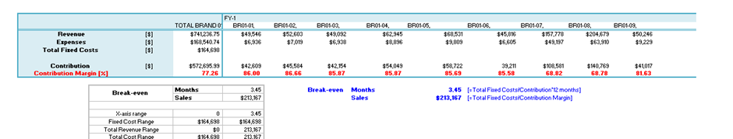

Diagram 5 - BEP Analysis in Innovation Management Decisions

The changes in the cost may allow the decision maker in the restaurant to further increase the price of beer to facilitate the revenue and profit, the sensitivity analysis will be examined to determine whether the restaurant should also increase the price, as shown in Diagram 6. From the result, the increase of price will result a higher profit before taxes only for products BR01-07 and BR01-08. Increase of price for products BR01-01 and BR01-06 will in turn reduce the profit, compared to the base case. Overall, the simulation result suggests that the decision maker should increase the wholesale price for BR01-07 and BR01-08. However, as a relatively small-sized brewery, Flushing Ale House should offer a price advantage to attract more consumers. Therefore, the price of beer will remain unchanged in the innovation management decision cycle.

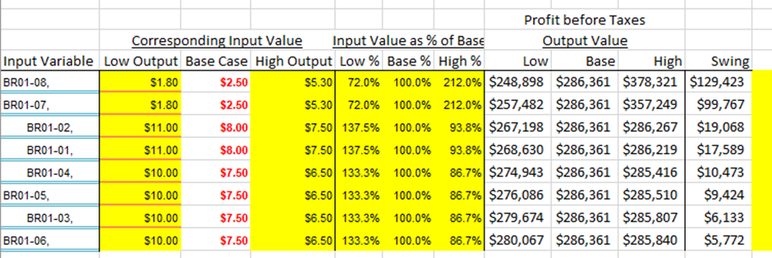

Diagram 6 - Sensitivity Analysis in Innovation Management Decisions

## 3.2.2 Decision Tools (Applied After the Submission of a Cycle)

After running a cycle in the simulation, Tab. Sim-Report analysis and Tab. Performance analysis is analyzed to help the decision maker in restaurant Flushing Ale House better assess the innovation strategies applied within the restaurant.

Tab. Sim-Report analysis can help the decision maker of Flushing Ale House analyze the change of innovation management parameters identified above, in comparison to the previous marketing cycle. As shown in Diagram 7, the total revenues remain unchanged after the implementation of innovation decisions. However, the profit before taxes increases from $1,264,147 to $1,284,018 and the net profit improves from $886,799 to $900,739. The enhancement in profit suggests the process technologies changes applied in the restaurant will effectively reduce the overall costs, which in turn improve the profitability for the restaurant.

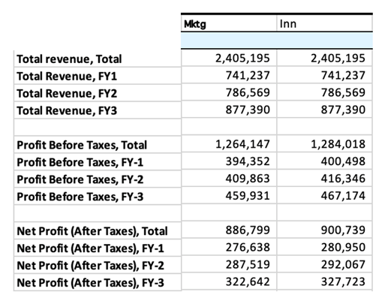

Diagram 7 - Tab. Sim-Report Analysis in Innovation Management Decisions

Tab. Performance analysis can help the decision maker of Flushing Ale House analyze the change of the efficiency ratios resulting from the process technology innovations. From the cost perspective, the efficiency ratio is calculated based on fixed costs, compensation and marketing costs, separately. From year 2 to year 3, fixed cost/total revenue ratio is falling from $0.24 to $0.23, and the compensation/total revenue is also decreasing from $0.09 to $0.08 (see Diagram 8). An increase in cost efficiency ratios indicate that the innovation decisions on reducing the fixed cost and compensation are successful to help the restaurant improve the efficiency. (Local advertising + Trade shows)/Total revenue ratio remained unchanged at $0.07 in 3 years, indicating no improvement in efficiency due to the innovative management decisions. From the profit perspective, profit before taxes/total revenue is used. From year 2 to year 3, the overall profit before taxes made for the overall sales of the beer products increases from $0.52 to $0.53 (see Diagram 8). An improvement in profit efficiency ratio indicates that the innovation decisions are successful in helping the restaurant Flushing Ale House improve the long-term profitability.

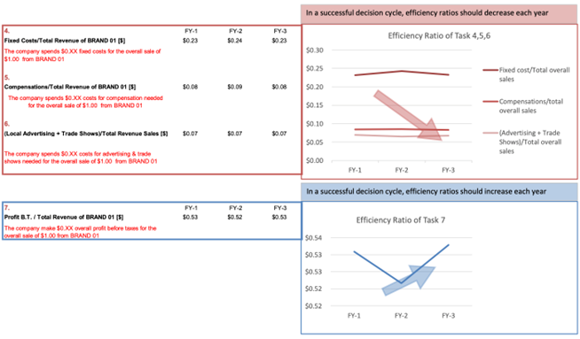

Diagram 8 - Tab. Performance Analysis in Innovation Management Decisions

## 3.3 Functional Area Organization and HR Management

## 3.3.1 Decision Tools (Applied Before Entering Assumptions)

SWOT analysis is the main decision-making tool used in organization and human resource management areas. There are two latitudes as our main considerations, including the base pay for each position and the amount of work necessary for each position. The base pay is a function of the average external competitive salary, mainly referred to at a reliable salary inquiry platform, Salary.com, but also reflects to some extent the importance of the position as well as the rights and responsibilities. As a small-scale enterprise whose organizational structure is close to simple structure, we need to improve the efficiency and effect of the use of funds as much as possible. Before entering the assumption, we analyzed the internal and external advantages and disadvantages of Flushing Ale House, so as to make better management decisions. In the Employees' Compensation form, the salesmen section is detailed, divided into full-time critical salesmen and part-time salesmen (0.25 person).

## 3.3.2 Decision Tools (Applied After the Submission of a Cycle)

Based on our strategic needs and goals, hiring the entire unit is not always necessary. The responsibilities of a full-time manager can be assumed by a senior salesperson, with a salary higher than the sales salary but lower than the manager's salary. Or give the manager a lower pay package but a 5% bonus for performance. In addition, there are many jobs that can be handed over to part-time office assistants and part-time salespeople. Professional consultants are not necessary in the current circumstances and can be adjusted according to future budgetary circumstances and operational requirements. Considering that our application of technology in the innovation management area reduces part of our labor cost, this part of the budget can be allocated to important positions to improve loyalty. Salesmen, both full-time and part-time, are our most important people, because they keep the store running and take away customer traffic if they lose to competitors. As a result, marketers' salaries and incentives need a larger budget in order to give marketers more money as an incentive. Initially, the analysis showed over budget, so we adjusted the salesmen budget to 36,000 through this table, so that our overall salesmen salary expenditure would be compared even more (see Diagram 9). For Workers' Compensation, it can be seen from the previous simulation that the total budget is 46,000 and the Total products in Fiscal Year 1 is 161163, thus 46,000 /161163=0.29. We worked out the variable cost of labor, and then went back to marketing management to run another cycle, changed labor to 0.29, and then ran another cycle of Organization and HR Management. An ideal surplus is obtained, with no negative numbers (see Diagram 10).

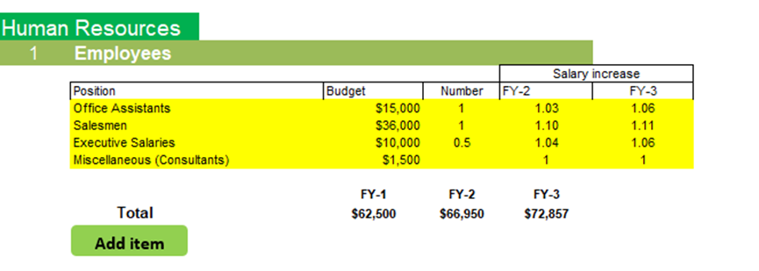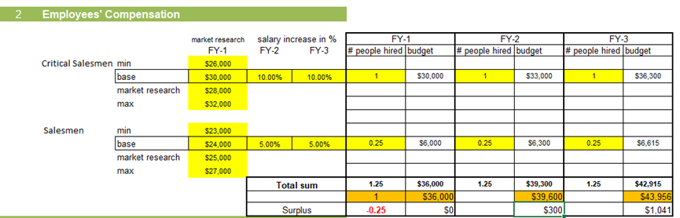

Diagram 9 - Changes on Employees Budget and Employees’ Compensation

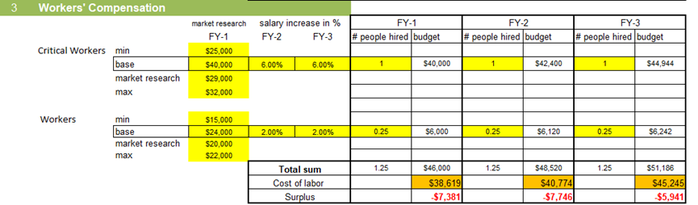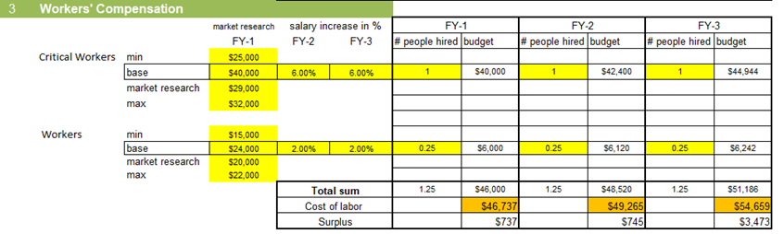

Diagram 10 - Changes on Workers' Compensation

# 4. Evaluation of the cycle

## 4.1 How changes made in different functional Area

We had run several cycles with the comparison of each previous cycle to find the most effective strategies in the business project. Operation management plays roles in multiple areas including manufacturing, design of goods and supply-chain management. In our simulation, we implemented capacity and constraint management with the assumption of build-to-order strategies (Holweg & Pil, 2001) that avoid exceeding demand or supply by adjusting the cut off points. After running cycles, most of the products have to decrease their cut off point in order to balance the demand with supply. As the result of implementing strategies, our in-house production has significantly achieved higher profits.

Additionally, innovation management is critical in improving the product quality without significantly increasing costs. Our modification mainly focuses on applying innovative technologies and processes such as the CIP system and ‘share economy’ ideas that bring relatively low costs to implement, and allow our business to produce a high-quality beer with cost-efficient benefits in both variable and fixed cost in the long run. Specifically, we reduced both ‘labor’ and ‘other cost’ on the variable cost section due to the innovation decision with $0.02 each, and reducing the cost for leasing the car and office supply cost due to the ‘share economy’ concept but the cost of heat has increased due to the conduction of CIP system. Most importantly, innovations help to differentiate our brand from the rivals.

Finally, effective HR management was also important to our Ale business success, as it prioritized employee satisfaction to deliver exceptional customer services. After conducting market research, we increased the salary of salesmen by reallocating a portion of the executive budget to decrease employee turnover and reduce costs linked with recruitment and training, and also improve productivity in both production processes and services. To ensure that we provide efficient worker compensation, we have increased the labor cost to $0.29. Even though the net profit after tax decreases 4% after modifying the organization management strategies, we still consider paying higher salary to the employees is necessary to ensure long-term benefits.

## 4.2 Best cycle analysis

The proposed new project is being evaluated based on multiple business cycles and strategies, each with its own set of priorities and goals including pricing and cost reduction. We believe our final cycle represents the optimal approach as it considers not only achieving high profits with a higher price but also strategically delivering and maintaining long-term benefits to our business. At this point, we have adjusted the fixed cost and variable costs with the implementation of innovations and found a balance in supply which does not cost pressured waste after being compensated by our special offer ale. Also, we had applied organizational decisions to provide employees/workers with a higher salary and compensation without affecting profitability trends. Our variable costs have a decreasing trend at the end of the fiscal year 3 and the total profit after tax for the three fiscal years is $891,855 with a constant increase, which gives room for future expansion and opportunities.

# 5. Summary

## 5.1 Summary of the Results

The report overall indicates favorable results with key performance indicators achieving their targets with a positive outcome. Due to the implementation of innovation management and the reallocation of salary budget among positions during the organization management process, the salaries expense has only grown $1000 and the total fixed cost has lowered by 2% compared to pre-improving cycles. From our break-even point and efficiency analysis, our break-even point is 3.49 months (Appendix 4) in this cycle which is acceptable for a relatively small-scale business, and the efficiency ratio has an overall increasing trend with minor fluctuation in the fiscal year 2 which was caused by a boost of target market size. According to the financial statement, Flushing Ale House has a steadily escalating net income after tax and cash balance (Appendix 5) during the three fiscal years with a 4% increase in year 2 and a 14% increase in year 3 due to the adjustments of management strategies.

## 5.2 Recommended Strategy

Based on the simulation data, the result shows that within 3.5 months, investors can cover the initial investment, in fiscal year 1. And the accumulated net profit from FY1 to FY3 is 891,855, and the total revenue is 2,405,199. When analyzing the investment decisions of Flushing Ale House, we intend to select its main financial indicators for calculation and use them as a reference for investment decisions. The asset-liability ratio of Flushing Ale House in FY-1 is 0.29 and the quick ratio is 1, which indicates that the company's financial leverage is low and the relative risk is small. During the period from FY-1 to FY-3, the gross profit margin growth rate of Flushing Ale House was 6.37% and 11.71%, respectively, which was in a state of rapid growth; The net profit growth rate was 4.27% and 13.94%, respectively, which was higher than the gross margin growth rate, which showed that Flushing Ale House expanded its revenue while better controlling other costs caused by the expansion of business scale. From FY1 to FY-3, the net cash flow generated by Flushing Ale House's operating activities was good, with growth rates of 23.12% and 41.49% respectively. The net cash flow of each period is fully sufficient to repay liabilities, pay dividends, and invest abroad.

## 5.3 Implementation Plan

To maximize revenue, our strategy will involve several key aspects. First is our prime location on Main Street, which could attract both tourists and residents. We will leverage this advantage by focusing on targeted social media campaigns and word-of-mouth recommendations to attract future customers while building strong brand identity in the community. In addition, we plan to partner with key opinion leaders (KOLs) to further promote our brand and attract even more tourists to our location.

Pricing will be a vital factor in our success, and we will use sensitivity analysis to ensure that our products are priced competitively within the region. Another significant strategy is innovation, which will help us to reduce costs while improving the quality of our products. Specifically, we will focus on implementing a clean-in-place (CIP) system to streamline our brewing processes, leveraging the sharing economy to reduce costs. By using modern technology and cost-saving techniques, we can optimize our operations and maximize profits. Finally, we will invest in human resources to ensure that we have the best possible sales team in place.

## 5.4 Conclusions

# 

# Reference

Burgelman, R. A., Christensen, C. M., & Wheelwright, S. C. (2008). Strategic management of technology and innovation. McGraw-Hill/Irwin.

Craft Beer & Brewing. (n.d.). The oxford companion to beer definition of cleaning in place (CIP). Retrieved May 4, 2023, from

https://beerandbrewing.com/dictionary/KkUPn95e3d/#:~:text=Cleaning%20In%20Place%20(Cip)%20refers,parts%20cleaned%20individually%20by%20hand.

Holweg, M., & Pil, F. K. (2001, October 15). Successful build-to-order strategies start with the customer. MIT Sloan Management Review. Retrieved April 28, 2023, from<https://sloanreview.mit.edu/article/successful-buildtoorder-strategies-start-with-the-customer/>

Jacobs, F. R., & Chase, R. B. (2020). Operations and supply chain management: The core. Mcgraw-Hill Education.

Marr, B. (2016, October 23). The sharing economy - what it is, examples, and how big data, platforms and algorithms fuel it. Forbes. Retrieved May 4, 2023, from https://www.forbes.com/sites/bernardmarr/2016/10/21/the-sharing-economy-what-it-is-examples-and-how-big-data-platforms-and-algorithms-fuel/?sh=2d7ab2fd7c5a

Salary.com. (2023). Make Fair Pay a Reality. Retrieved from https://www.salary.com/

Zlatev (2023). Slide Deck (Class 12). Boston University MET AD715 Spring 2023 Quantitative and Qualitative Decision-Making.

# Appendices

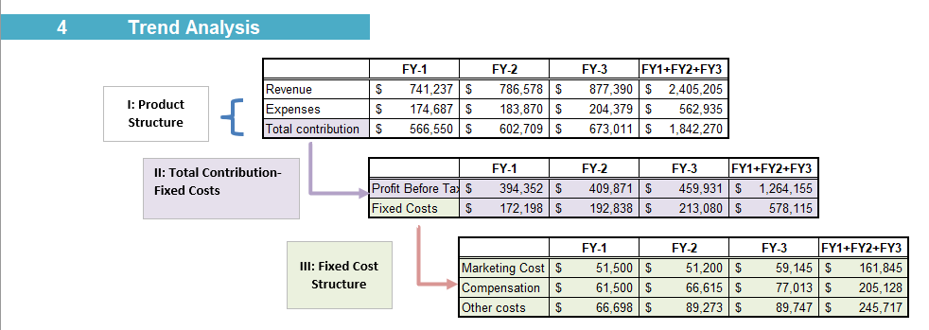

Appendix 1 - Trend Analysis in Operation Management

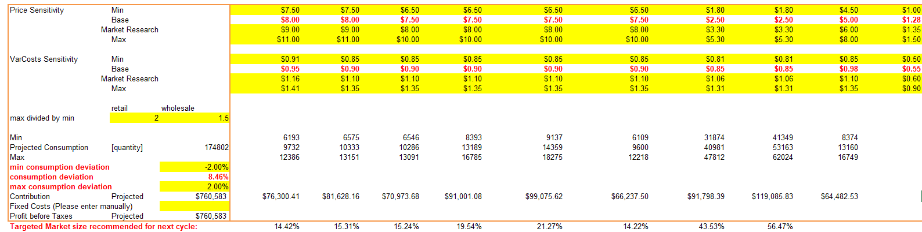

Appendix 2 - Optimization analysis before Solver in Operation Management

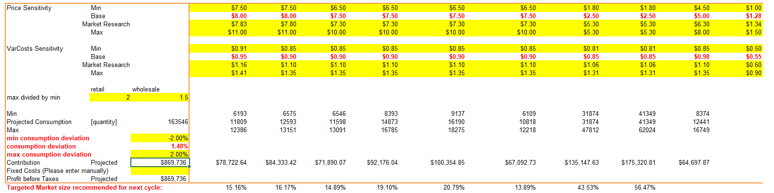

Appendix 3- Optimization analysis after Solver in Operation Management

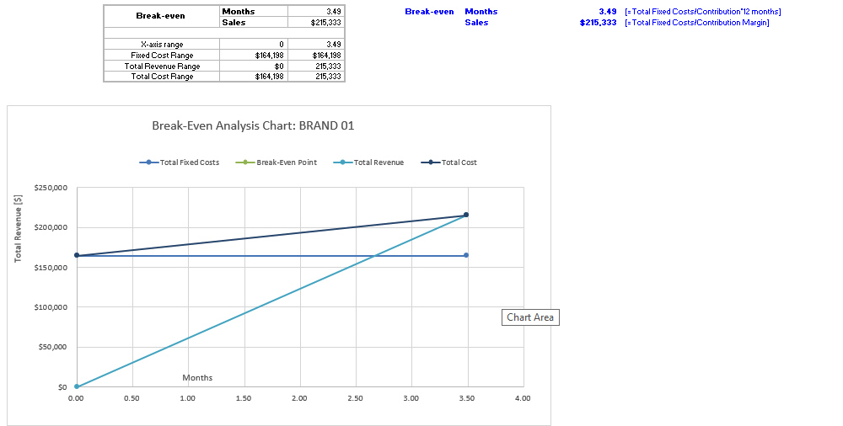

Appendix 4- Break-even Analysis of the best cycle

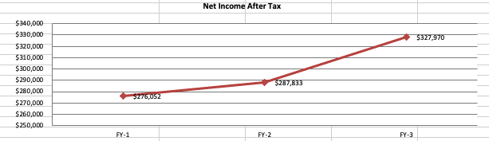

Appendix 5- Net Income After Tax in Financial Statement